ABOUT PRODUCT

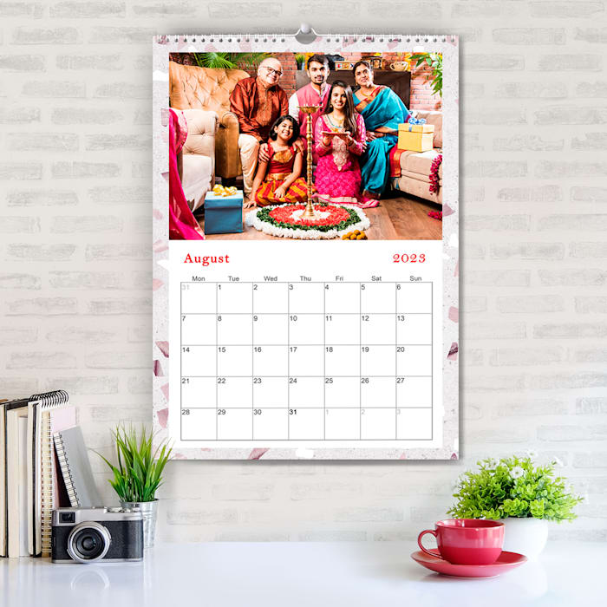
- JANUARY.2023 TO DECEMBER. 2023 - 2023 monthly wall calendar covers 12 months from January 2023 to December 2023, help to track your daily tasks and long-term goals so you can get more done in less time. Each month features one page for better life organization.

- PREMIUM THICK PAPER - The paper of this calendar is designed to prevents ink through and avoids feathering, which can keep your every page clean.

PRICE= RS 999

